Lab 3: Audio-Driven Kinetic Sculpture with Infrared Control
EECE.5520 - Microprocessor II and Embedded System Design
Himadri Saha, Daniel Burns, Chris Worthley
Nov. 23, 2025

- General Information
Student Name: Daniel Burns
Student ID number: 01996432
Team Name/Number: Unknown
Team member names: Himadri Saha, Chris Worthley
Date of completion: 11/23/25
Demonstration method: zoom

Hardware Design
Our lab was to create an Audio controlled motor, with IR control capabilities. The hardware in this lab is rather simple. The main components are the IR controller and sensor, LCD display, motor and fan, and sound module. The First part of the hardware design is to set up the correct pins on the Arduino for the components. The first component is the IR sensor of the controller. This component is simple, and has a VCC and GND connection, and one output pin for the Arduinos GPIO. The output pin is connected to pin D13 on the Arduino. The second component is the LCD display. The LCD display also includes an RTC to get the starting time of the lab and display it. RTC uses I²C so there is SDA, and SCL lines, each using the analog input pins. The pins used are A4 for SDA, and A5 for SCL, along with basic VCC and GND power for the RTC component. The RTC is then used for the LCD display, but that connection is done through software. The LCD display has pins on the component itself. There are 11 pins on the display, so I will list the pins:
(VSS) → GND
(VDD) → 5V
(VO) → GND or pot wiper
(RS) → D7
(RW) → GND
(EN) → D8
(D4) → D9
(D5) → D10
(D6) → D11
(D7) → D12
(LED+) → 5V
(LED–) → GND
The left side of the list is the LCD display pins, and the right side, is the Arduino connections. The last component is the DC motor and driver associated with it. The first part is the pin connections to the Arduino. For the enable input on the driver (pin 1) connects to the PWM pin at D5. The next connections are the two input pins at pins 2 and 7 on the driver. Pin 2 connects to D4, and pin 7 connects to D3 on the Arduino. The next part is the drivers connections to the DC motor. The driver connects both its output pins 3 and 6, to the DC motors input pins. Then I connect the power pins from the driver to the DC motors power supply, with pins 8 from the driver. Pin 8 is specifically made for the motor because it can output higher voltage around 5-9 volts. The second power pin is made for the Arduino. This power supply only takes in 5 volts from the Arduino, to then use in the driver. The driver uses pin 16, and connects directly to the VCC pin on the Arduino. The last pins for the driver are the ground pins, which are 4, 5, 12, and 13. The last part of the hardware design is the button to switch between CW and CCW. This button connects to D2 on the Arduino, and connects to GND.

Software Design
There are 4 main states in this program. These states are shown in the FSM diagram in figure 1. Before all of the states, we have a set up function that initializes all the variables, LCD output, and timers used in the lab. The loop function in this program is the main driving function that calls all of the other functions. The loop function encapsulates all the states of the FSM diagram, the other functions are mainly called to help make the components function properly, and to keep the code organized. The first state is the idle state, this mainly takes place in the beginning. This state checks for the button to see what direction to spin the motor, read in the sound sensor values, and calculate the “volume” in a sense, and setting the LCD display to the time given by the RTC that we initialized in the setup function. After taking in the sound sensor values, the code already checks if the seconds are equal to 0, which means that a new minute has started, and the motor can start. This begins the run state. In this state we start the motor, and apply the direction determined by the button, and using the sound sensor data we collected, we compare it to the threshold values using if statements. Then using those statements and thresholds, we set the speed of the motor based on how the collected data compares to the threshold values. Then after 30 seconds of operation, we compare the motor start time subtracted from the seconds, to determine if the motor has ran for 30 seconds. If that is true the motor is turned off, which puts the program in the pause state. This state still reads in all the data and updates the LCD display every loop iteration, but waits 30 seconds before entering the idle state again and repeating the process. The final state comes from the IR sensor and controller. This state is called only when the IR sensor detects a command from the remote, and calls an interrupt, and overrides the code. When the IR sensor is triggered, depending on the signal take in, the code flags a certain variable. Whether it’s the pause/play variable, or the increase/decrease speed control variable. These variable are also being probed for in the if statements, to check if any interrupts occur. For the increase/decrease variables, they check the speed label, and moves up or down one speed depending on the variable called. The pause and play variable interrupts the code and directly stops the motor and enters the pause state, and holds it there ignoring the start of a new minute, and will only continue when the play button is pressed, where it will return to the run states, and perform as it did prior. The IR state just processes the data using a helper function. The controller’s signal comes into the sensor as a hex number specific to each button, which is then deciphered and applied to these interrupt variables. Also, the number buttons are each coded with a specific hexadecimal value, so we can read in the number that is selected and use it in other part of the code. The IR section looks to see if the function button is pressed before recording the numbers are entered. Then using the entered numbers in order, they overwrite the time given by the RTC and now continues using the new time. That is the entire process of our program.
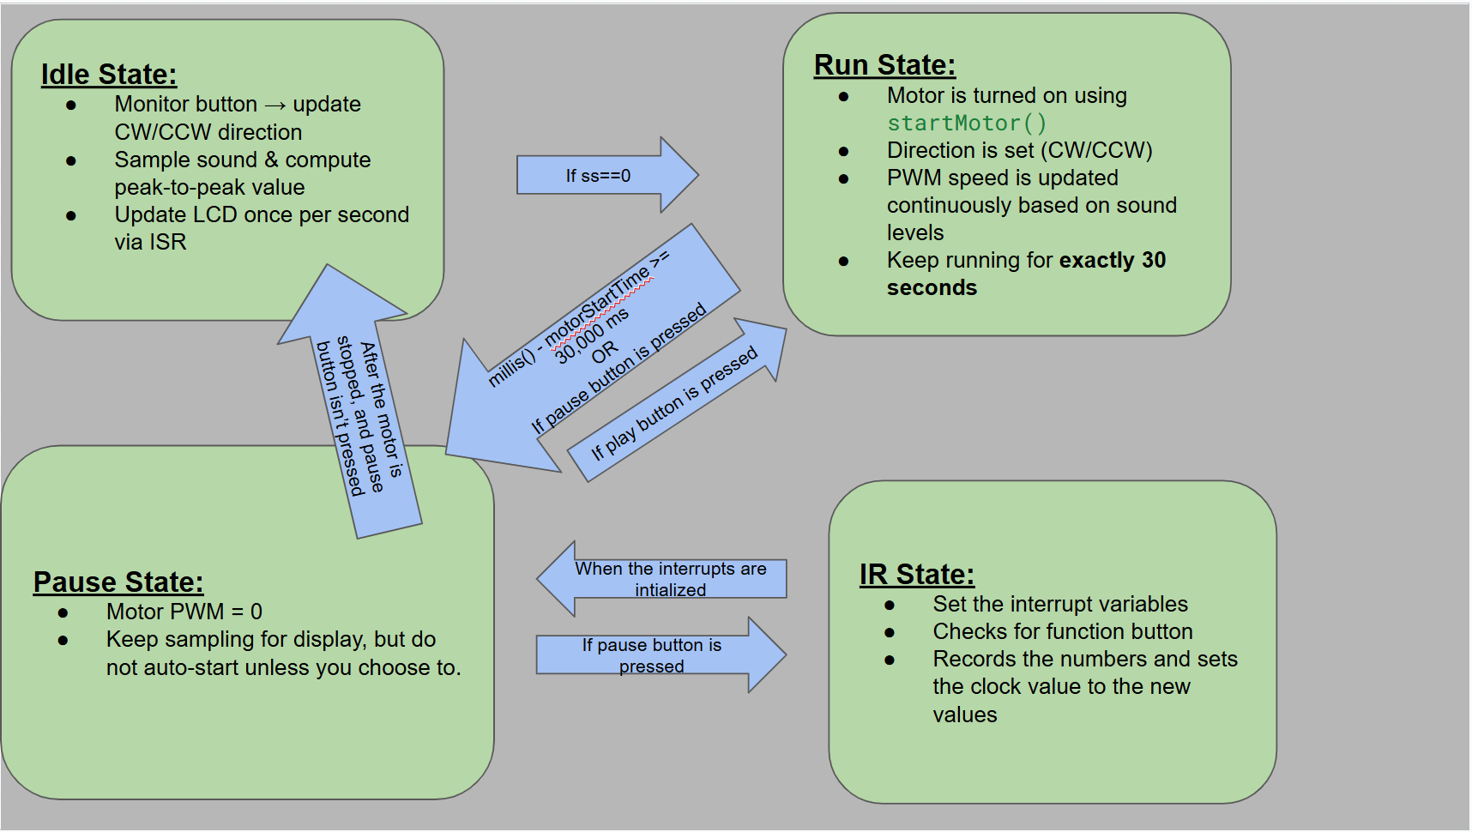
Figure 1. FSM diagram

Results
This lab had a few issues in the beginning due to some component issues, specifically our DC motors, but overall, our result was successful. We were able to combine all the necessary components into a working program that controlled volumes based on sound and IR controller input. Although the output was a little finicky with certain sound volumes, it works rather reliably. I assume that issue mainly has to do with the sound value being very close to the dividing thresholds between speeds. Along with that, the IR sensor and controller worked great. The interrupts all took priority over the main function and were also able to resume control back to the main function without causing issues in the performance. Finally, the LCD display and RTC component both worked together well, and there were no issues getting the data from the RTC to the display. LCD display properly displayed the time and was able to use that updated time and continue incrementing it. Overall, this lab was successful in taking sounds through a sensor and using that to manipulate a DC motor’s speed. Along with connecting a real time clock and using an IR controller to overwrite the program.

Problems Encountered and Solved
We had a couple big problems when trying to tackle this lab. The first problem we had, was that one of our group mates broke their motor drivers IC. This made it very hard to test, since he was originally in charge of working on the hardware for this lab. However, after this issue was resolved, he swapped to working on the software. The second issue we had was with the DC motor itself. We had a hard time getting it properly set up and working on the Arduino. We eventually figured it out, and found out our issue was we were mixing up some of the pinouts for the driver. Once we verified the pins were all secured to the proper spots, the DC motor worked well. The last big error we had was setting up the interrupts for the IR sensor. The code would sometimes ignore the speed increase/decrease variables. This had to do with the fact we didn’t compare the variable to the speed value saved in the string, which made the code just use the normal value that was being measured. After a quick rewrite of the code we fixed the issue and the code worked perfectly.

Personal Contribution - Daniel Burns
In this lab I was initially tasked with setting up the hardware for the lab. But I don’t have the kit for the class, so instead they put me on researching the parts, and brainstorming how to add the IR section of the code. After brainstorming and sharing my ideas, the other two group members each coded a good section of the code, and one built the circuit. Which then left me with writing the report and setting up the FSM diagram for the software design section. I was around for the whole project, and kept up with the group, but with my schedule being a little busier with track I wasn’t able to work on the project as often. So we decided as a team, that I would write the entire report.

Personal Contribution – Chris Worthley
I was given more of the hardware parts of the lab, since one of the other group members has broken their driver’s IC. I learned how to properly pin up the components like the DC motor and its driver, the sound sensor, and the LCD display. After figuring out the pin configuration, I wrote a preliminary code for the entire project except the IR section. This code went into good detail, and was a strong skeleton for our final code. When writing that code, I had to figure out how to set up and display the time on the LCD display. I also had to figure out how to properly send the PWM signal through the driver, to the DC motor to get the fan to spin at different speeds. Finally I had to figure out a way to compare the peak to peak values of the sound sensor in order to use to influence the speed of the fan.

Personal Contribution – Himadri Saha
I was going to make the hardware for this lab, but I recently discovered that my DC motor driver’s IC is broken. So, I had to change my plan and focus on other components and software. I changed my focus to the IR sensor and finalizing the code as a whole. Since I haven’t coded using an IR sensor and controller, I had to research how it worked and received data. I learned that the IR controller outputs a signal that gets interpreted by the IR sensor as hexadecimal values. These values are also specifically coded for each button on the remote. This made the coding easy. I just looked up the datasheet for the controller and found the hexadecimal value of the buttons I needed, and hard coded them in, and treated them as a Boolean value. After getting the IR sensor down, I focused on making the IR sensor class, and how they interrupt the program to perform their task. Interrupts were needed since the IR controller would override the original programs data, and take priority. After properly integrating that section, I essentially just cleaned up our skeleton code, and implemented IR section. Then I tested the whole program to verify=y it works properly.

Lessons Learned
In this lab we learned how to use multiple new components, and software functions. Specifically, we learned how to properly wire up a DC motor along with its driver, an LCD display, an IR sensor, an RTC, and sound sensor. These are new components we have not used yet this year. With new components comes new software functions. In this lab we learned how to call and use the lcd.XX() functions to control the LCD display. We also learned how to read the sound sensor data, and make a function output the peak to peak value. We also learned how to use the RTC to keep real time data, and apply it to the code. The last thing we learned was how to use a PWM with this specific DC motor, and adjust it to affect the speed of the fan.

